Getting a Frontend Developer Job

The Three Users -Strengths, Weaknesses and Gotchas

* We have to focus on the users
* Just like we focus looking for a job
* Who will be interacting
* You are competing who may(most likely) have more experience than you.
* You have to plan your “Portfolio”, “Resumes” “Codepen” etc. perfectly.

The Three Users

1. HR Tech & Bots

* Strength-Can Scan info very quickly ex) How old are you? How many years of experience?
* To minimize the time.
* You have to use the key words as strong and as much as possible as well as your portfolio.
* Weakness- Not empathic, Hard Data only.
* No real work around.
* It’s a Robot

1. HR Recruiters

* Strength- They are humans, they have empathy, creativity, they can be influenced.
* You can influence their decisions
* Weakness- **They don’t have much time.**
* The Average looking websites for humans is about 6 seconds per website
* You have to make sure what you are doing “pops” or has all the keywords readily available.
* Their specialty is HR(Human Resources). NOT “Tech”
* They don’t really have a deep understanding which can be a win or loss depending how they use it.
* Decisions can be influenced by what design or what you build.
* When it comes to websites, deep-down, 80% of people care about
* Is it fast?
* Does it look good?
* Does it work?

1. Tech Lead/ Team

* Can be a little bit more scary if it’s your new job.
* These people already had the job and basically can say you can go or not.
* So all the terms you’ve been studying on like “Interview cake”, “Mozilla MDN”, these are the people that you can be using them on.
* Who asks all the boring stuff.
* We have to deal w/ the world.
* Weaknesses- We have to train for the worst case scenarios. Some Tech are against bootcamp, self taught, CS Grads etc. We have to prepare and overcome the things that we encounter.

Technologies you Need To know-As an entry level developer

Strong Understanding of the big three

* HTML -Why you do a certain way (Semantic Web, SEO)
* CSS- little bit of animation. Should be able to understand grid and flex as well as understanding why.
* JS-should need to understand even older writing style such as Jquery (How to Turn JQuery to JS)

Technologies to give you an Edge

* That gives you a shine
* Design Systems
  + <https://www.usds.gov/>
  + <https://code.gov/>
* Web Accessibility

-One of a big pizza company got hit by a large lawsuits

-Have a deep understanding of AA and AAA web accessibility

<https://www.w3.org/WAI/standards-guidelines/wcag/>

-Make sure you know them clearly

* Usage of APIS

-You will be able to know how to talk about APIS

<https://github.com/vets-who-code/api-list>

* Serverless-

-Where the market is going for example Google Cloud

<https://serverless.css-tricks.com/>

These things above will add firepower to your resume.

-Even a surface level will put you ahead of your competition.

Building your Resume

1. One thing that no developer focuses on- Is their copy and their writing abilities

-You have to focus on being a good writer.

<https://books.google.com/books/about/The_Elements_of_Style_Workbook.html?id=sddfuQEACAAJ&source=kp_book_description>

1. Introductory Pitch

-This is the most important part of the resume.

-A strong lead captivates the user that entices them to investigate more.

* Teachers recommend writing an “introductory Statement” before even starting to build a website. - It helps mold making the website.
* Introductory statement focuses on diligence over passion. You need to show diligence even though you are not motivated.

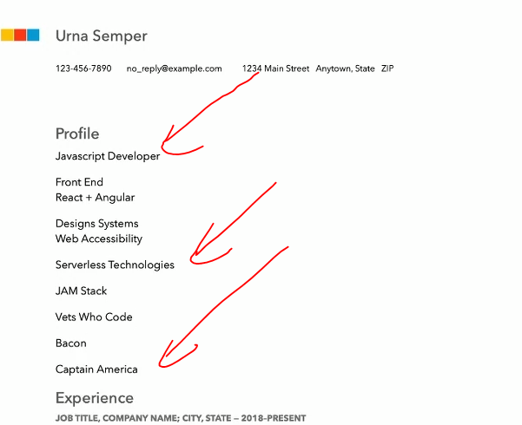

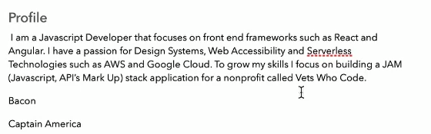

Linkedin

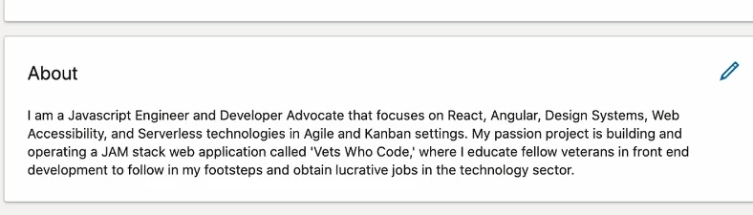

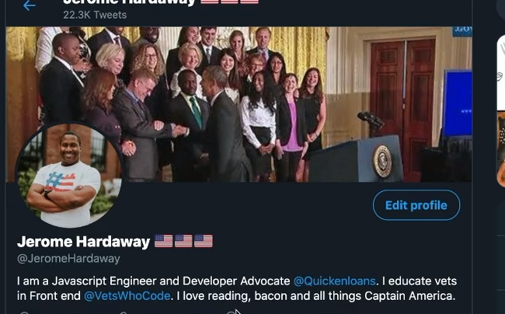

Education-

Teacher has 0 experience in technical stuff.

-Guess don’t put anything that is irrelevant.

-If you don’t have a CS Degree, put education in the most bottom

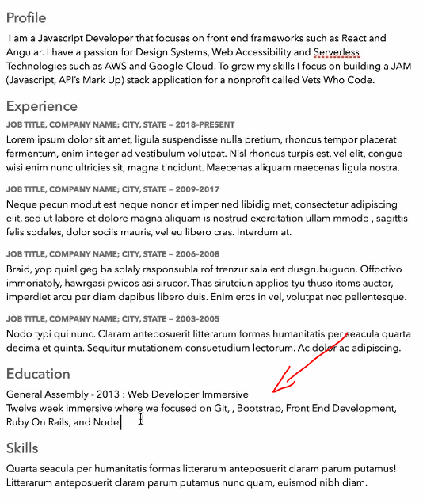

-make sure no typos

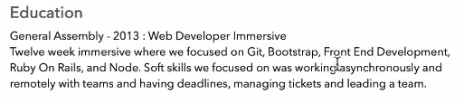

-Education that is irrelevant.

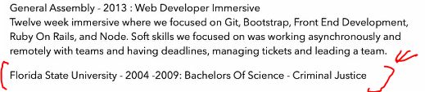

-How to put in online courses that doesn’t have a schedule

-Or doesn’t have a completion course.

-you can talk frontend developer completion.

-every company is looking for potential.

Experience

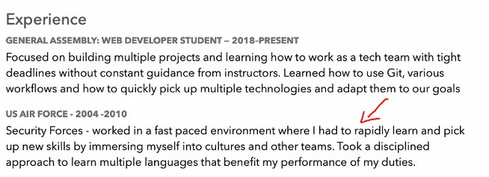

-Try to extract what people in the teach needs (fast pace, language in above)

Volunteering-

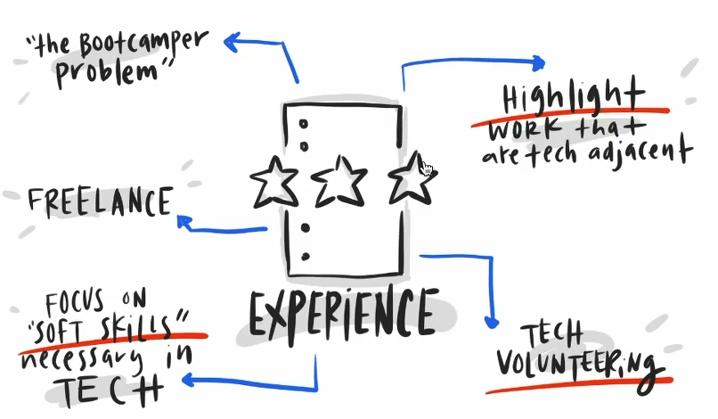

-Make sure proof read three times, then give it to someone else to look over your resume.

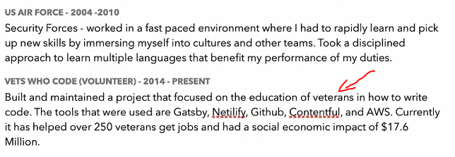

-Managers absolutely love you understanding business value

Resume Q & A

* What if you experienced unemployment
  + Explain during the interview.
  + The tech field is pretty forgiving for those things
* How do you handle a bad relationship with an employer or client?
  + Make sure you extract the good things.
* Try to put everything in one page
* Keep resume as simple
* A strong resume will get you a better job.

Employer-Ready Github Profile

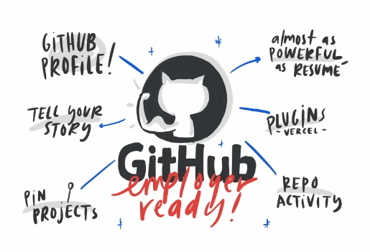

Introductory Pitch Practice-

Take 10 minutes to come up with a strong introductory pitch

* Somehow “Full Stack” word has a negative impact so “Web Developer” is better
* -creative, focus on the client,
* I make accessible website using front-end technologies with a focus on product design.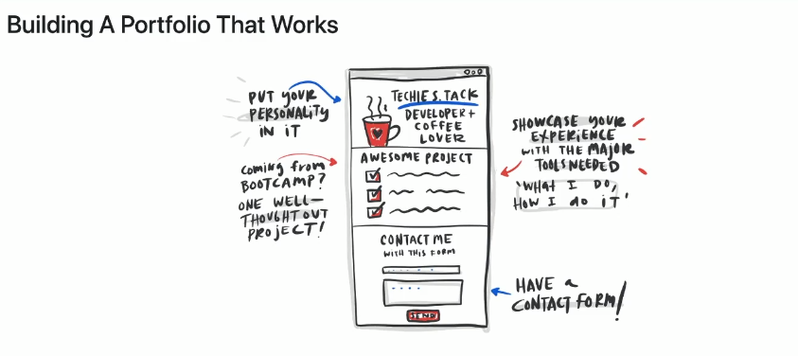

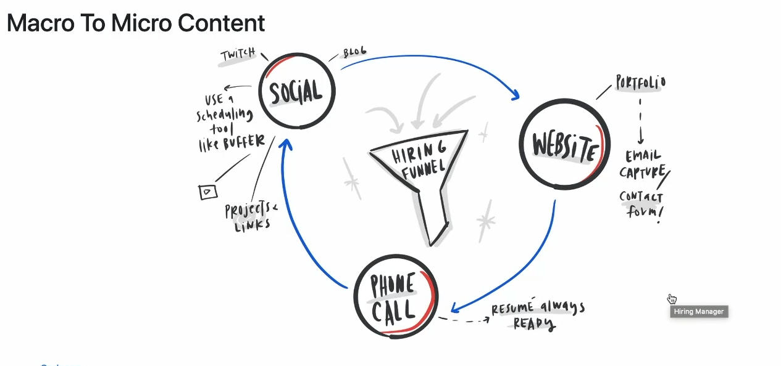

<https://dev.to/>

Twitter

<https://twitter.com/GregCurl2>

Try to put one bullet what you did that isn’t technical but relates

Have to do did this thing - impact the business, social

-data impact (maybe open) able to work professionally that did

-making a story one

We have to focus on always building things-pushing things out

Writing our resumes of how we shine out the best.

Focus being the best piece of the puzzle

MAKE A TWITTER ACCOUNT!

<https://twitter.com/ThePracticalDevv>

<https://twitter.com/CodeNewbies>

Slack

https://github.com/ladyleet/tech-community-slacks#new-england